Rustin Invitational

Science Olympiad 2017-2018

Ecology - Answer Key

Division B

January 6, 2018



School Name: ____________________________________

Team Number: ____________________________________

Student Names: ___________________________________

**Instructions:**

* Turn in all exam materials at the end of this event. Missing exam materials will result in immediate disqualification of the team in question. There is an exam packet and a Scantron sheet.
* You may separate the exam pages, but you must re-staple them as you submit your materials to the supervisor.
* Write your school name and team number in the appropriate locations on the Scantron as well as on the title page of the packet. Indicate the names of the participants on the title page. Write LEGIBLY.
* Only the answers provided on the Open-Ended section and Scantron will be considered. Do not write outside the designated spaces for each answer. Write LEGIBLY.
* All multiple choice questions are worth 1 point. All short answer questions are worth 2 points, unless otherwise noted.
* Tiebreaker questions are identified with a (T#) indicating the first, second, third, etc. There are 10, and they do not appear in numerical order. Tiebreaker questions count toward the overall grade, and are only used as tiebreakers in the event of a tie.
* When the time is up, the time is up. Continuing to write after the time is up risks immediate disqualification.
* Resource is as per the Science Olympiad Student Manual. “Each team may bring one 8.5” x 11” sheet of paper that may contain information on both sides in any form and from any source along with two non-programmable, non-graphing calculators **dedicated to computation**.” **No other resources are permitted.**

|  |  |
| --- | --- |
| ***Test Section*** | ***Possible Points*** |
| Part 1: Multiple Choice | /65 |
| Part 2: Open-Ended | /20 |
| **Total** | **/85** |

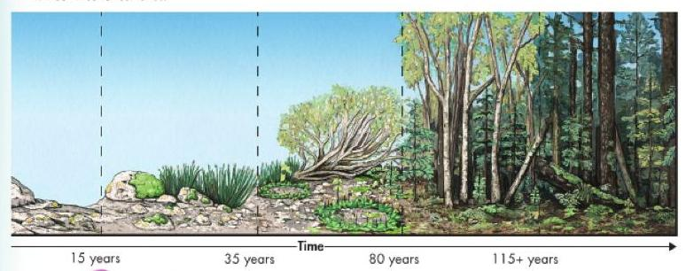

1. Which of the following is a structural change in a community and its nonliving environment over time that alters the ecosystem as shown in the above visual?
   1. Natural selection
   2. Evolution
   3. Adaptation
   4. Succession
2. What organisms are found in the climax community for this ecosystem shown in the above visual?
   1. lichens and moss
   2. weeds and grasses
   3. trees and shrubs
   4. volcanoes and soil
3. Primary succession would most likely occur after
   1. a forest fire.
   2. farm land is abandoned.
   3. a severe storm.
   4. lava flow.
4. **(T#1)** The bigger the number calculated on the Simpson Index, the
   1. More diverse an area is.
   2. the lower the diversity of an area is.
   3. The more interaction there is between two species.
   4. The less interaction there is between two species.
5. A glacier has just receded across the landscape. As the glacier retreated, it completed decimated all standing vegetation. The landscape recovers quickly because there are plenty of seeds left in the seed bank. What is this an example of?
   1. Primary succession
   2. Secondary succession
   3. Tertiary succession
   4. Quaternary succession
6. The process which converts the ammonia into nitrite ions which the plants can take in as nutrients:
   1. Ammonification
   2. Nitrogen Fixation
   3. Denitrification
   4. Nitrification

Use the following scenario to answer questions # 7 - 10. A population of birds eats the green moths that live in a pine forest. Every so often, the green moths have a brown offspring. The brown moths are usually seen more quickly by the birds and are eaten sooner.

1. The fact that the brown moths are easier to see and are less likely to survive as a result is known as:
   1. evidence
   2. mutation
   3. variation
   4. natural selection
2. Which of the following statements is TRUE?
   1. the brown moths are possibly a result of a mutation
   2. the brown moths increase the variation within the moth population
   3. both a and b
   4. none of the above
3. The green moths survive in the forest because:
   1. their coloring makes them better adapted than the brown moths
   2. they fly faster than the brown moths
   3. both a and b
   4. none of the above
4. Imagine that increased population cause the pine trees in the forest to be heavily covered with brown particles. What is most likely to happen?
   1. The green moths would survive, but would become covered in brown particles.
   2. The green moths would be less likely to have more brown offspring in order to survive.
   3. C. The green moths would be less likely to be eaten by birds. Over time, the moth population would still have more green moths.
   4. The brown moths would be less likely to be eaten by birds. Over time, the moth population would have more brown moths.
5. What is the typical percentage of loss of energy in transfers from one trophic level to the next?
   1. 10%
   2. 25%
   3. 60%
   4. 90%
6. Scorpions are small, but pack a powerful, venomous sting. Why are they considered secondary consumers?
   1. They only eat small shrubs and trees
   2. They feed on primary consumers like insects, mammals and lizards
   3. They are able to make their own food using the venom to provide energy for the rest of the food chain
   4. They are the top predators in the ecosystem

Use the following diagram to answer questions 13 - 15.

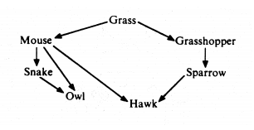

1. Which of the following is an autotroph?
   1. Grass
   2. Grasshopper
   3. Owl
   4. Sparrow
2. Which of the following organisms is most likely to be located at the apex of the pyramid of biomass?
   1. Grass
   2. Grasshopper
   3. Snake
   4. Mouse
   5. Hawk
3. All of the following statements about the diagram are correct EXCEPT
   1. The grasshopper is an herbivore.
   2. Only two trophic levels are depicted.
   3. The mouse and grasshopper are at the same trophic level.
   4. The grass is a producer.
   5. All of the organisms except grass are consumers, regardless of position.
4. The environment most vulnerable to pollution is
   1. Aquatic
   2. Forest
   3. Soil
   4. Grassland
5. How does human intervention NOT affect the nitrogen cycle? 
   1. Nitric Oxide (NO) is released into the atmosphere when any type of fuel is burned. This includes byproducts of internal combustion engines. 
   2. Nitrous Oxide (N2O) is released into the atmosphere through bacteria in livestock waste and commercial fertilizers applied to the soil. 
   3. Adding nitrogen to the Earth’s crust and soil during the mining of nitrogen-rich mineral deposits. 
   4. Discharge of municipal sewage adds nitrogen compounds to aquatic ecosystems which disrupts the ecosystem and kills fish.
6. Which of the following graphs represents a population undergoing logistic growth? Answer is A
   1. 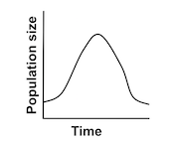 c. 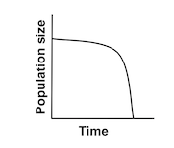
   2. 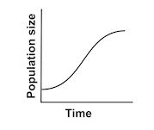 d. 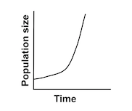
7. Water lilies do not grow in desert sand because water availability to these plants in a desert is
   1. a limiting factor.
   2. the carrying capacity.
   3. a competition factor.
   4. none of the above
8. Which population is limited by a density-dependent factor?
   1. A deer population is reduced as a result of a forest fire.
   2. A local wolf population experiences a lethal epidemic of parvovirus.
   3. Many eggs in a population of frogs are destroyed due to a drought.
   4. A population of rams is decimated by an earthquake.

***A food web is represented in the diagram below.***

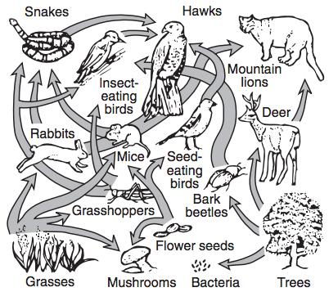

1. A food web shows the flow of ____________________ through an ecosystem.
   1. Consumers
   2. Population
   3. Energy
   4. Matter
2. Which organisms are correctly paired with their roles in this food web?
   1. (Producers) mountain lions, bark beetles (Heterotrophs) hawks, mice
   2. (Consumers) snakes, grasshoppers (Autotrophs)mushrooms, rabbits
   3. (Consumers) birds, deer (Producers) Grasses, trees
   4. (Decomposers) Seeds, Bacteria (Heterotrophs) Mice, Grasses
3. The organic and inorganic materials in all of the organisms in the diagram will eventually return to the environment by the action of
   1. decomposers
   2. Producers
   3. primary consumers
   4. secondary consumers
   5. top carnivores
4. Which level of biodiversity includes the available habitat in an area?
   1. Species diversity
   2. Genetic diversity
   3. Ecosystem diversity
   4. All of these
5. The evaluation of biomes takes into account which of the following?
   1. Latitude
   2. Temperature
   3. Precipitation
   4. Both temperature and precipitation
6. A species that exerts a large, positive impaction on its ecosystem is known as a:
   1. Indicator species
   2. Keystone species
   3. Invasive species
   4. Poached species
7. Which of the following is not a reason for the fragility of desert ecosystems?
   1. Top predators are usually not checked in growth and can grow exponentially.
   2. There is a lack of water
   3. Plant growth is slow
   4. There is a low species diversity.
8. The variety of processes, including matter cycling and energy flow within ecosystems, which results from species interacting with one another in food webs is called:
   1. species diversity
   2. functional diversity
   3. ecosystem diversity
   4. intellectual diversity
   5. genetic diversity
9. Globally, the leading cause of biodiversity loss is
   1. invasive species
   2. poaching and overharvesting
   3. pollution
   4. habitat change and loss

The graph below shows the growth of a field mouse population in an ecosystem over time.

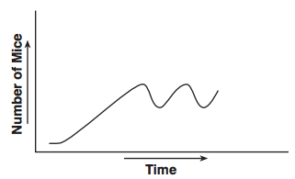

1. The dashed line indicating the carrying capacity for the mouse population is correctly shown on which graph?
   1. 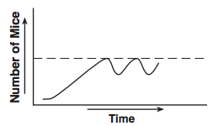 c. 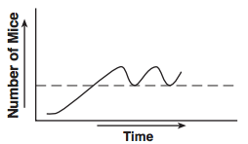
   2. 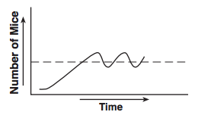d. 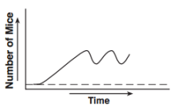

**B is the correct answer**

1. Invasive species leads to all of these problems except:
   1. Loss of biodiversity
   2. Loss of native species
   3. Increased biodiversity
   4. Disease
2. What do competition, predation and food availability have in common?
   1. They are all abiotic factors
   2. They are all biotic factors
   3. They are all limiting factors
   4. Nothing
3. What type of plants rarely grow in the grasslands?
   1. Grasses
   2. Sagebrush
   3. Wildflowers
   4. Tall Trees
   5. Clover
4. Which of the following terrestrial ecosystems or life zones produces the lowest net primary productivity per year?
   1. extreme desert
   2. temperate forests
   3. Tundra
   4. swamps and marshes,
   5. Savana
5. Which of the following is not a part of the phosphorus cycle?
   1. Rocks
   2. Atmosphere
   3. Soil
   4. Organisms
   5. marine sediments
6. **(T#2)** Which of the following scenarios represents a density-independent limit on population?
   1. Porcupine population growth is limited by the spread of a disease.
   2. Box turtle population growth is regulated by a hurricane that destroys their nests.
   3. Caribou population growth is limited as a result of grass depletion.
   4. Woodpecker population growth is regulated by opossum predation of woodpecker eggs.
7. Which of the following is not a major contributor to the greenhouse effect?
   1. Carbon dioxide
   2. Chlorofluorocarbons
   3. Carbon monoxide
   4. Methane gas
8. Vultures, which are classified as scavengers, are an important part of an ecosystem because they
   1. hunt herbivores, limiting their populations in an ecosystem
   2. feed on dead animals, which aids in the recycling of environmental materials
   3. cause the decay of dead organisms, which releases usable energy to herbivores and carnivores
   4. are the first level in food webs and make energy available to all the other organisms in the web

* 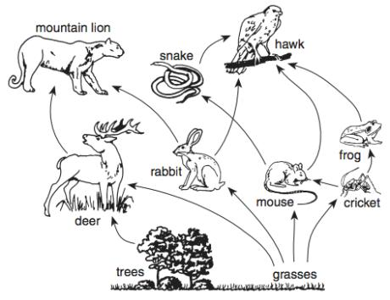

1. Which organisms are *not* shown in this diagram but are essential to a balanced ecosystem?
   1. Heterotrophs
   2. Autotrophs
   3. Producers
   4. Decomposers
2. What is the original source of energy for this food web?
   1. chemical bonds in sugar molecules
   2. enzymatic reactions
   3. the Sun
   4. chemical reactions of bacteria
3. If the population of mice is reduced by disease, which change will most likely occur in the food web?
   1. The cricket population will increase.
   2. The snake population will increase.
   3. The grasses will decrease.
   4. The deer population will decrease.
4. **(T#3)** As habitats become fragmented, the amount of edge effect
   1. Increases
   2. Decreases
   3. Remains the same
   4. It’s irrelevant
5. **(T#4)** The graph below represents the amount of available energy at successive nutrition levels in a particular food web. The *X*s in the diagram represent the amount of energy that was most likely: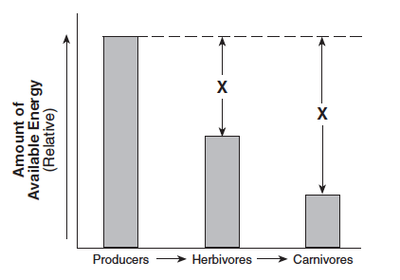
   1. changed into inorganic compounds
   2. retained indefinitely by the herbivores
   3. recycled back to the producers
   4. lost as heat to the environment
6. The number of individuals per unit area or volume is known as the
   1. population density
   2. population distribution
   3. carrying capacity
   4. limiting factors
7. The cichlid species of Lake Victoria were drive to, or nearly to, extinction by the introduction of:
   1. North American sturgeon
   2. Bass
   3. Nile Perch
   4. Eel
8. Which of the following best explains why there are seldom more than five trophic levels in food chain?
   1. Most carnivores function at more than one trophic level
   2. Trophic levels above this number contain too many individuals
   3. Top carnivores are too few in number to prey effectively
   4. The ecosystem contains too much biomass
   5. Energy is lost from each trophic level
9. All deserts are found in:
   1. very arid (dry) areas.
   2. very hot areas.
   3. very wet areas.
10. **(T #5)** The IPAT equation expresses:
    1. Variables associated with invasive species
    2. Human impact on environment
    3. Population distribution
    4. Increased biodiversity
11. Deserts are areas which:
    1. have less than 250 mm of rainfall per year.
    2. have less than 250 cm of rainfall per year.
    3. have less than 25 m of rainfall per year.

|  |  |
| --- | --- |
| 1. **(T #6)** The value of biodiversity falls into the categories of:    1. aesthetic, ethical, and indirect economic    2. direct economic, indirect economic, aesthetic, and ethical    3. direct and indirect economic    4. aesthetic and ethical | |

1. **(T #7)** The most pervasive form of habitat disruption is
   1. Urban development
   2. Clear-cutting forests
   3. Grazing
   4. Industrial development
2. Deserts are found in:
   1. areas of low air pressure.
   2. close to the North and South Poles.
   3. areas of high pressure.
3. Ozone depletion is caused by
   1. Nitrous oxide
   2. Carbon dioxide
   3. Chlorofluorocarbons
   4. Methane
   5. All of the above
4. Plants which are able to store water are called:
   1. Clever.
   2. Succulents.
   3. Sahel.
   4. Lush
5. A group of similar organisms that can mate with each other and produce fertile offspring:
   1. Community
   2. Biome
   3. Species
   4. Habitat
6. A tick and a dog is an example of what kind of symbiotic relationship:
   1. Commensalism
   2. Competition
   3. Mutualism
   4. Parasitism
7. **(T #8)** Biodiversity is a measure of:
   1. variety of nonliving things within an ecosystem
   2. amount of resources shared by the human population
   3. variety of species within an ecosystem
   4. amount of renewable resources in an ecosystem
8. True or False? Grassland biomes are large, rolling terrains of grasses, flowers and herbs.
   1. True
   2. False

Use the energy pyramid below to answer the next two questions.

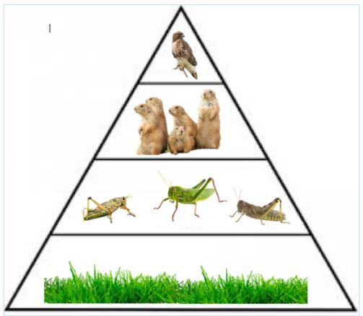

1. What will most likely happen to the prairie dogs and the hawks if the grasshoppers are removed?
   1. The prairie dogs will eat more hawks.
   2. The prairie dogs will eat fewer hawks.
   3. There will be more prairie dogs and hawks.
   4. There will be fewer prairie dogs and hawks.
2. **(T #9)** If the grasses have 10000 kcal of energy, how much energy is available for the secondary consumer?
   1. 10 kcal
   2. 100 kcal
   3. 1000 kcal
   4. 10000 kcal
3. Sulfur dioxide contributes to all of the following problems except
   1. damage to buildings.
   2. Acid rain
   3. Death to vegetation
   4. Loss of biodiversity in aquatic ecosystems
   5. Photochemical smog
4. Which of the following is not a type of grassland?
   1. Pampas
   2. Chaparral
   3. Savanna
   4. Boreal
   5. Shrubland
5. Which of the following is not a likely result of global warming?
   1. Rising sea level
   2. worsening health effects
   3. increased storm frequency and intensity
   4. increased agricultural productivity worldwide
   5. all of the above are likely results of global warming
6. At nighttime, desert temperatures
   1. Stay scorching hot
   2. Cool down to a warm and balmy temperature
   3. Often cool down to freezing temperatures
   4. Vary significantly from desert to desert
7. **(T #10)** Which of these is not a grassland bird species?
   1. Sharp-tailed Grouse
   2. Gilded Flicker
   3. Mountain plover
   4. Sedge wren
   5. Sprague’s pipit

Open-Ended:

1. What are the three major types of community interaction:
   1. ________________ (predation)
   2. ________________ (competition)
   3. ________________ (symbiosis)

Base your answers to questions 67 through 70 on the food web and graph below. The graph represents the interaction of two different populations, *A* and *B,* in the food web.

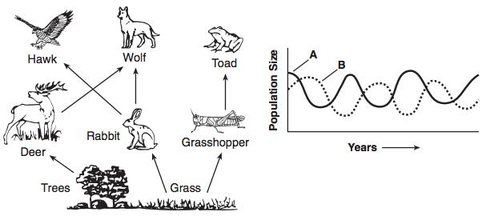

1. Population *A* is made up of living animals. The members of population *B* feed on these living animals. The members of population *B* are most likely
   1. scavengers
   2. autotrophs
   3. predators
   4. Parasites
2. Identify one heterotroph from the food web that could be a member of population *A. ______________________________* (**rabbit** *or* **grasshopper** *or* **deer.)**

#### How are heterotrophic organisms divided in the ecological study of food interactions?

__________________________________________________________________________________________________________

Heterotrophs are divided into consumers and decomposers

An energy pyramid is shown here. 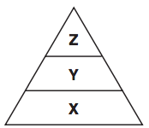

1. Identify one organism shown in the food web that would be found at level *X.*

*_________________________________________* (trees or grass)

1. What organisms are usually the pioneer species in a new area? How do these organisms prepare the area for other species?

_________________________________________________________________________________________________________________________________________________________________________________________________________________________________________________________________________

Species are usually **lichens** and **mosses**, which can grow on bare rocks. As they grow, the **lichens** and **mosses** help break up the rocks to form soil.

1. Determine the type of symbiotic relationship described. In the desert, the wasp will lay its eggs inside the eggs of praying mantis. So when the wasps hatch, they will feed on the larvae inside the mantis eggs then makes it way out of the egg.

_________________________________________ (Parasitism)

1. Determine the type of symbiotic relationship described. In some deserts, bees will depend on cacti since they're a major food source for them. As cacti depends on bees to pollinate them so they can continue to reproduce.

_________________________________________ (Mutualism)

1. Determine the type of symbiotic relationship described. In the desert, the Cactus Wren will make its nest in the tall Cholla Cactus to protect its young offspring from predators. The cactus is not harmed but not benefited.

_________________________________________ (Commensalism)

1. The loss in land productivity caused by drought, overgrazing and farming is known as: _______________________________________ (Desertification)